|  |  |  |  |
| --- | --- | --- | --- |
| **Campus** | **NPI** | **C:\Users\dell\AppData\Local\Microsoft\Windows\INetCache\Content.MSO\6682F1C2.tmpC:\Users\dell\AppData\Local\Microsoft\Windows\INetCache\Content.MSO\BDCB720.tmp** | Please Tick (✓) for  **Re-do Assignment** |
| **APU Foundation & Degree**  **Programmes** | |  |

**Coursework Submission and Feedback Form**

|  |  |  |  |  |  |
| --- | --- | --- | --- | --- | --- |
| **Name** | **Jiten Chapagain** | | | | **Name of Group Members (If Applicable)** |
| **Student No.** | **NPI000150** | | **Intake:** | **NPI1F2202IT** |  |
| **Module Code & Title** | **CT042-3-1( Introduction to Database)** | | | |  |
| **Assignment Title** | **UPA library management system** | | | |  |
| **Name of Lecturer** | **Er.Isha Baral** | | | |  |
| **Date Due** | **2022/06/23** | **Student E-Mail: jitenchapagain2202it@infomaxcollege.edu.np** | | |  |

*I have read and understood the regulations on Plagiarism and Academic Dishonesty and declare that the work submitted does not breach those regulations.* **Signed: ________________________________**

**You must hand in to the designated APU Administrator – ensure that you receive your receipt**.

|  |  |  |  |  |  |  |  |
| --- | --- | --- | --- | --- | --- | --- | --- |
| **Received By** |  | **Signature** |  | **Date** |  | **Time** |  |

|  |  |  |  |  |  |  |  |  |  |  |  |
| --- | --- | --- | --- | --- | --- | --- | --- | --- | --- | --- | --- |
| **Criteria** | | | **Weighting** | | **Fail** | **Marginal**  **Fail** | **Pass** | | **Credit** | | **Distinction** |
|  | | |  | |  |  |  | |  | |  |
| **Additional Comments:** (These may be listed below or attached) | | | | | | | | | | | |
|  | | | | | | | | | | | |
| **Provisional Assessment Result:                                                                                          Grade            Date                Lecturer’s Initial**  **C:\Users\dell\AppData\Local\Microsoft\Windows\INetCache\Content.MSO\159DCA2E.tmpC:\Users\dell\AppData\Local\Microsoft\Windows\INetCache\Content.MSO\55FC666C.tmpC:\Users\dell\AppData\Local\Microsoft\Windows\INetCache\Content.MSO\9427D35A.tmp**  Taking account of above factors, the overall provisional assessment of your work is: | | | | | | | | | | | |
|  | | | | | | | | | | | |
| **Distinction** | | **Credit** | | | | **Pass** | | | | | |
| **A+: 80-100%** | **A: 75-79%** | **B+: 70-74%** | | **B: 65-69%** | | **C+: 60-64%** | | **C: 55-59%** | | **C-: 50-54%** | |
| **Marginal Fail** | | **Fail** | | | | | | | | | |
| **D: 40-49%** | | **F+: 30-39%** | | | | **F: 20-29%** | | | **F-: 0-19%** | | |

*The comments and assessment result are subject to both internal and external moderation at the appropriate Examination Board.*

*Consequently, they may not reflect your final grade. You may not appeal against this result on ground of Academic Judgement.*

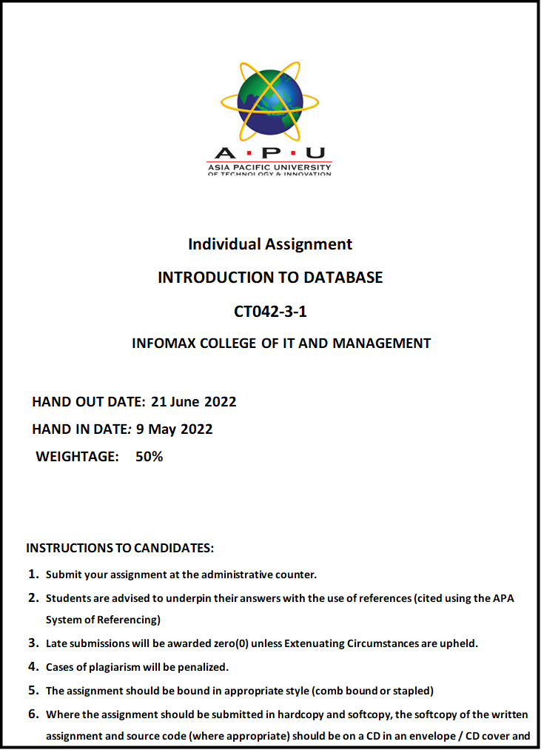**NPI000150 INDIVISUAL PART**

**Individual part: DDL**

Screen shot and table are given below of query and their respective result.

**Database**

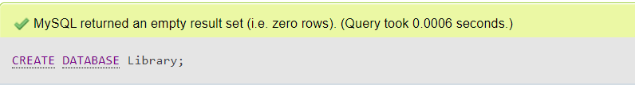

Fig 1: create database

**Book**

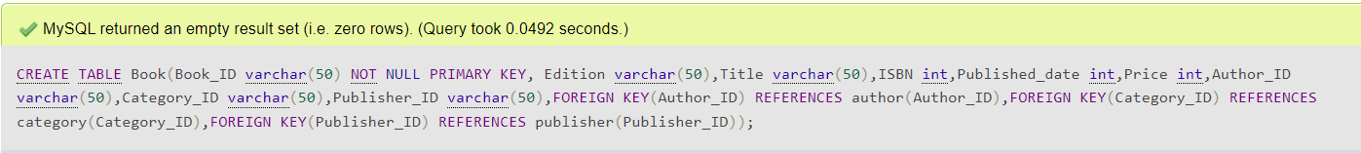

Fig 2: create table

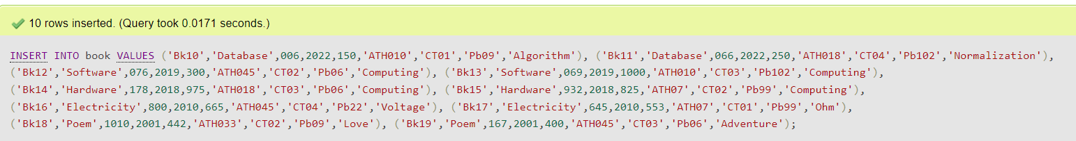

Fig 3: Insert value in book table

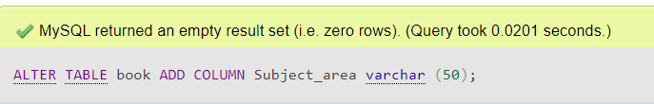

Fig 4: Adding column in book

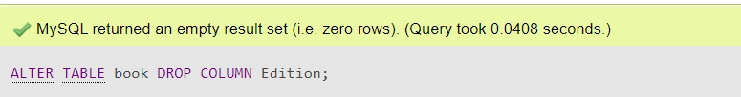

Fig 5: Drop column in book

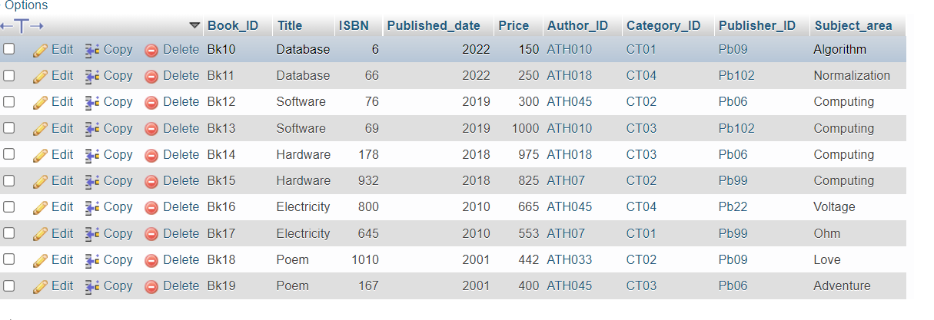

Fig 6: Overall table of book

**Author**



Fig 7: Query to create author table



Fig 8: Query to insert value

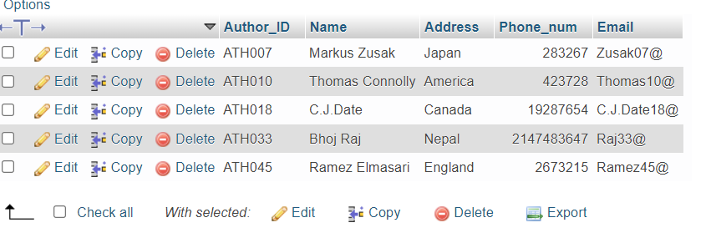

Fig 9: Overall table of Author

**Bill**



Fig 10: Query to create bill table

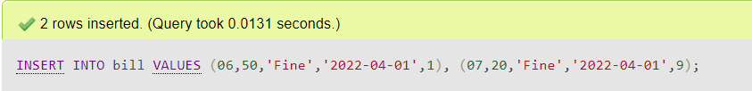

Fig 11: Query to insert value in table

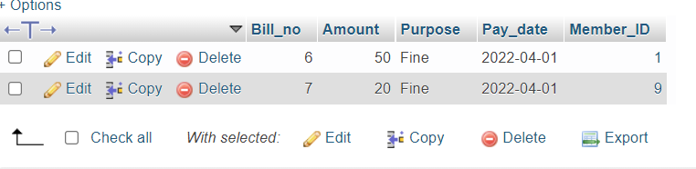

Fig 12: Overall table of bill

**Book_loan**



Fig 13: Query to create book_loan table

Fig 14: Query to insert value in table

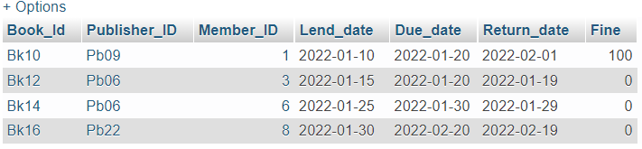

Fig 15: Overall table of Book_loan

**Category**

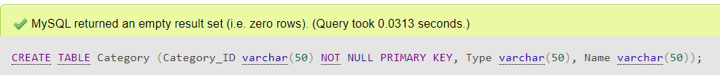Fig 16: Query to create Category table

****Fig 17: Query to insert value in table

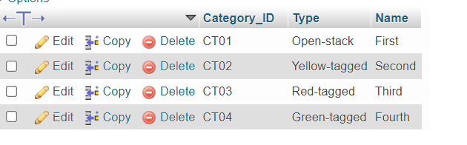

Fig 18: Overall table

**Department**

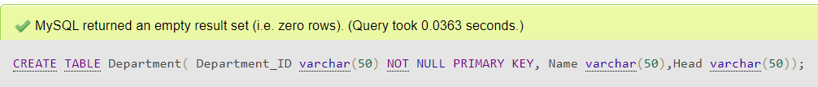Fig 19: Query to create department table

****Fig 20: Insert values

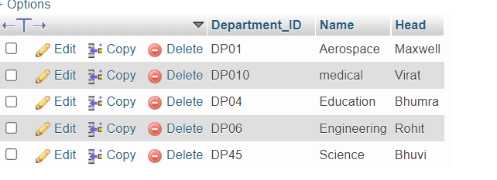

fig 21: Overall table

**Member**



Fig 22: Create member table

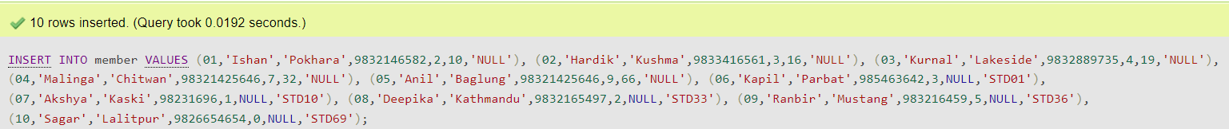

Fig 23: insert values in table

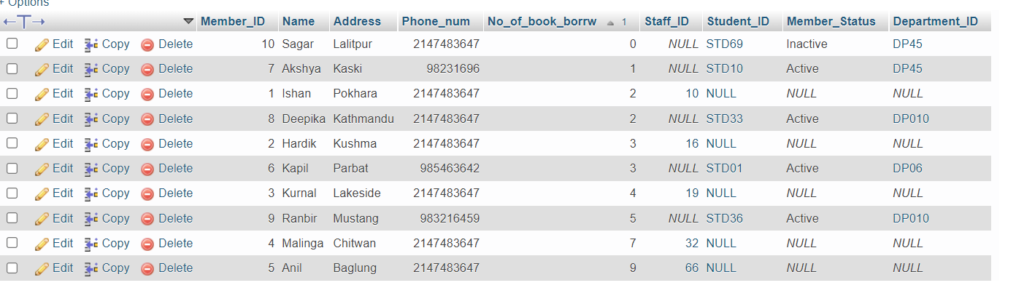

Fig 24: Overall table

In this table member status and Department_ID are added to connect the member table and department table directly.

Query to ADD those column in that table are:

Alter table member add column Member_status varchar (50);

Alter table member add column Department_ID varchar (50);

**Publisher**



Fig 25: Query to create publisher table



Fig 26: Insert values

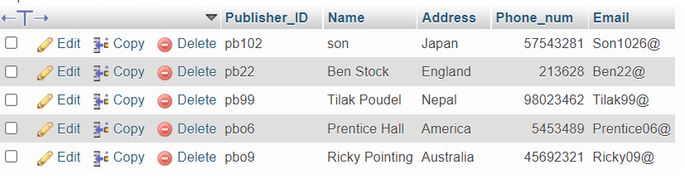

fig 27: Overall table

**Report**



fig 28: Create report table



fig 29: Insert values

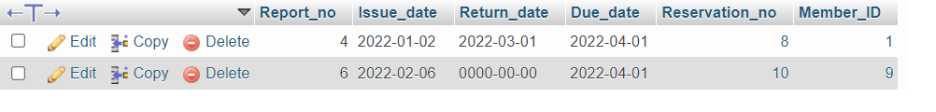

fig 30: Overall table

**Reservation**



fig 31: Query to create reservation table

 fig 32: Insert values

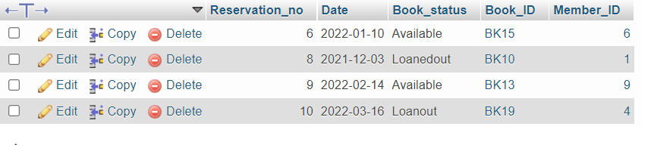fig 33: Overall table

**Staff**

****fig 34: Create staff table



fig 35: Insert values in table

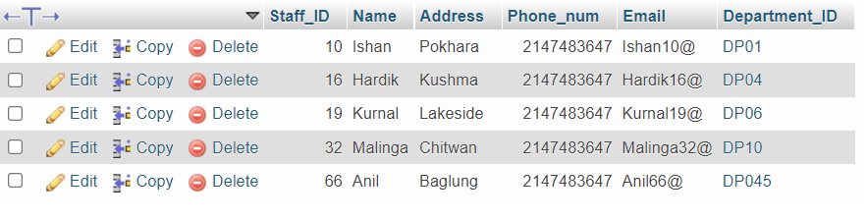

fig 36: Overall table

**Student**

****Fig 37: Query to create student table

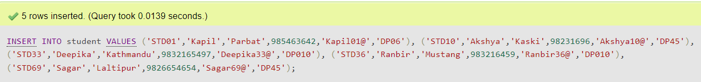Fig 38: Query to insert values in table

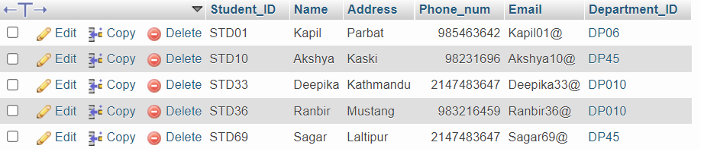

Fig 39: Overall table

**DML**

Sql data manipulation language:

From the question number 2.

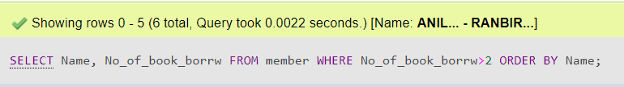

fig 40: command

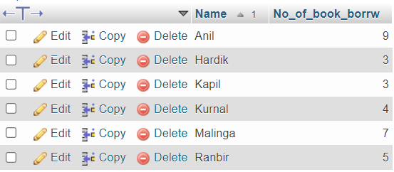

Fig 41: Outcome

**b)**

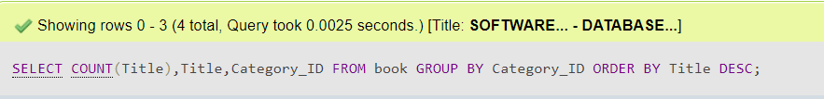

Fig 42: command

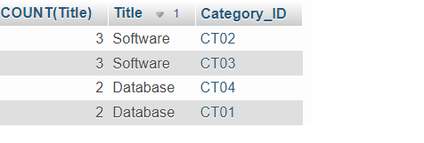

fig 43: outcome

**c)**

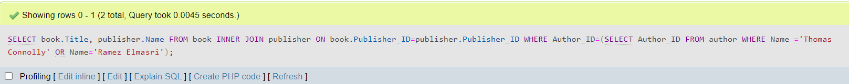

fig 44: command

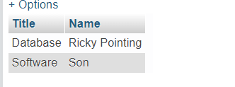

fig 45: outcome

**d)**

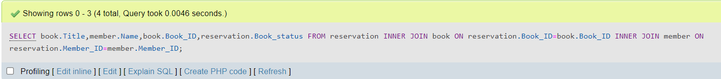

Fig 46: command

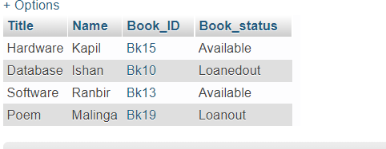

Fig 47: outcome

**e)**



Fig 48: command

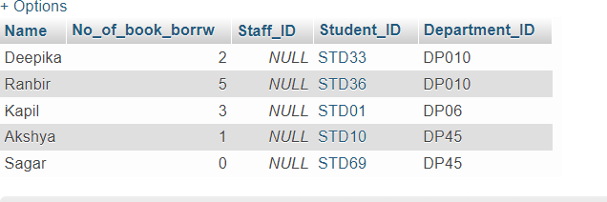

Fig 49: outcome

**2 f)**

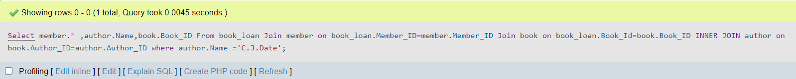

Fig 50: command



Fig 51: outcome

**2 g)**



Fig 52: command

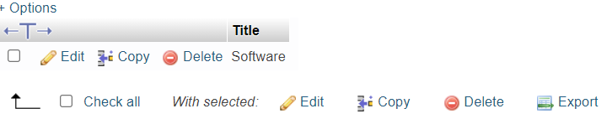

Fig 53: outcome

**h)**



Fig 54: command

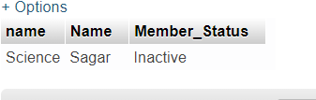

Fig 55: outcome

**I)**



Fig 56: command

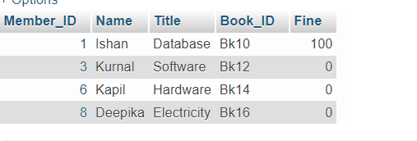

Fig 57: outcome

**J)**

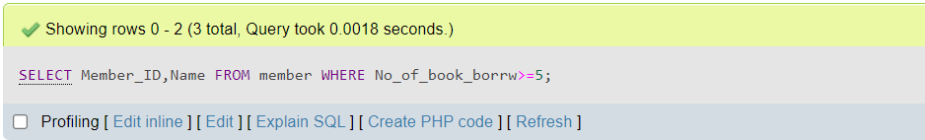

Fig 58: command

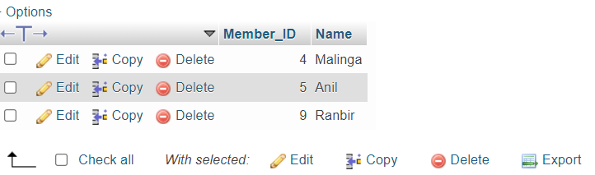

Fig 59: outcome

**k)** 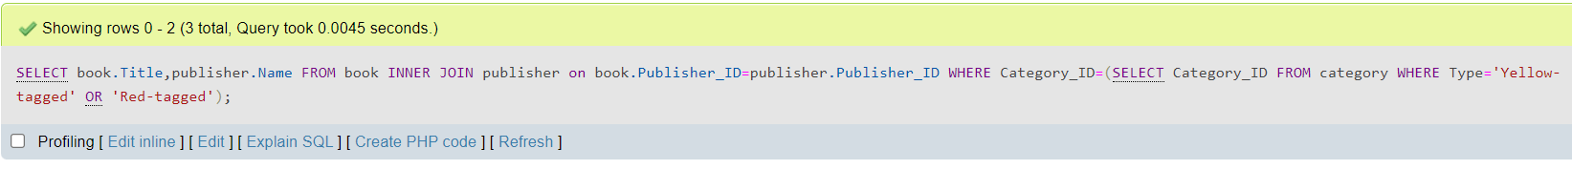

Fig 60: command

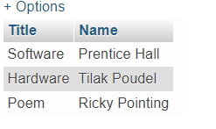

Fig 61: outcome

**l)**



Fig 62: command

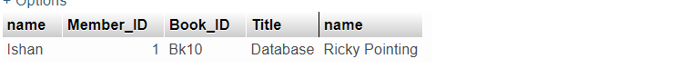

Fig 63: outcome